**THE CHURCH OF THE HOLY TRINITY**

**RATHMINES**

**Chris Owen**

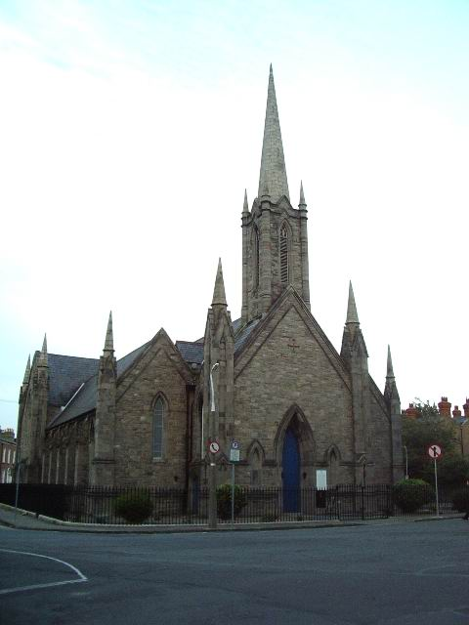

**Modern picture of Holy Trinity Church**

**Copyright Alexander P Kapp and licensed for reuse**

**In fulfilment of the requirements of the Lord Mayor’s Certificate in Local Studies May 2014**

**(Tutor Dr Séamas Ó Maitiú)**

**INTRODUCTION**

This paper is written for the Lord Mayor’s Certificate in Local Studies, which is offered by Dublin City Council, and held in the Dublin City Library & Archives, 138-144, Pearse Street, Dublin 2 under the tutelage of Dr Séamas Ó Maitiú. In the course of my research for this essay I received much help from others who gave freely of their time to answer my questions. I would like to thank Mrs Mary Furlong and Mrs Jennifer Murphy, of the RCB Library, Braemor Park, Churchtown, Dublin, 14. I am especially indebted to the Rev Canon Neil McEndoo, Rector of Holy Trinity Church, Rathmines for all his assistance and access to his own research documentation.

In the paper I will briefly discuss the development of Rathmines; the building of the Church of The Holy and Undivided Trinity in Rathmines (hereafter Holy Trinity Church) in the early part of the nineteenth century and its subsequent development into a Parish in its own right; and other parochial buildings.

**RATHMINES, THE EARLY DAYS**

In her book *Four Roads to Dublin* Deirdre Kelly describes the early days of Rathmines. ‘The lands of Rathmines once formed a portion of the property of the See of Dublin and were included in the manor of St Sepulchre. They were part of the Parish of St Peter and, in pre-Norman times, of the Parish of St Kevin. The names Rathmines originated in the family of de Meones who came into possession of what was referred to as ‘the Rath’ in the early 14th century. It had previously been held by Richard de Welton. In 1382 the Rath was held by William de Meones, who styled himself Lord of Meonesrath. At some time the name was inverted to Rathmines, or it may simply have been a corruption of Rath de Meones. In early times the area was probably heavily wooded and much of it would have been part of Cullenswood.’[1]

Another picture of Rathmines can be seen in *Thom’s 1846 directory* in a preamble to detailing information on the inhabitants of Rathmines.

‘An extensive village and district, suburban to the metropolis, in the Parish of St Peter’s Without, Uppercross barony, Dublin County, two miles south from the General Post Office, Dublin comprising an area of 413 acres. Population 2,429 inhabiting 379 houses. It is situated on the mail coach road to Kilkenny..... Little more than 20 years ago, it was an insignificant village but is now one continued line of elegant buildings, upwards of one mile and a half in length, intersected by numerous terraces with detached villas and only separated from the city at Portobello by the Grand Canal, crossed by the Latouche bridge and where the municipal and parliamentary boundaries terminate……The Kilkenny day mail passes every morning at a quarter to 9 and every evening at a quarter to 5 o’clock; and Rathfarnham omnibuses pass the road five times each day at fares of 6d inside and 4d outside.’[2]

**THE DESIGN AND BUILDING OF THE ORIGINAL HOLY TRINITY CHURCH**.

The church was designed by John Semple, (c. 1801 to c. 1873). As the Church was consecrated in 1828 it would have been built in the 1826/1827 period and would, undoubtedly, have been designed in 1825 so that the design could have been approved by all of the interested parties in advance of any building estimates and contracts being finalised. John Semple must have been a very gifted architect since he would have been only 24 years old at the time. However, I wonder if there could possibly be some confusion between John Semple and his father, also called John Semple, who had earlier designed the Round Room in the Mansion House. Peter Costello, in his book, describes Holy Trinity Church thus:

‘Another of the Dublin churches of John Semple, ‘the presiding genius of the Board of First Fruits’ in Maurice Craig’s phrase. It has his distinctive pinnacles and deep-set windows and doors. The three wide gables, the tall steeple and the rather plain exterior are all typical of this period and the architect. The church was opened in September 1833 [Sic.], and stands on an island in the middle of the road where Belgrave Road meets Church Avenue. It was erected at a time when the upper parts of Rathmines Road and Palmerston Road were being developed.’[3]

The United Parishes of St Peter’s and St Kevin’s were given the land in 1826 on which to erect the church. The original Grant of Deed states that ‘One Rood [one quarter of an acre] Irish Plantation Measurement of lands of Cullenswood in Co. Dublin was granted to the Heirs and Successors of the Churchwardens of St Peter’s in perpetuity at an annual rent of one peppercorn, if lawfully demanded’. This is recorded in a Deed that was registered in the Registry of Deeds on the 25th January, 1826 between:

The Rt. Honourable the Earl of Meath, 1st Part

Thomas Smith White, esq. of Nevistown in County of Meath, 2nd Part

Samuel Houghton, the younger, of County of Carlow and Thomas Houghton of Craigue in the Queen’s County, 3rd Part

Ven. John Torrens, DD, Archdeacon of Dublin and Minister of the United Parishes of St Peter’s and St Kevin, 4th Part

John Minchin of Fitzwilliam Square and Walter Jones of Harcourt Street in the County of Dublin, 5th Part. [These two gentlemen were the then churchwardens of St Peter’s.][4]

In the Bond of Indemnity, dated the 4th day of April, 1826, issued by William Moyers, Builder, Minchin Lucas and William George Eades to The Venerable John Torrens, Archdeacon of Dublin, Mr Moyers

‘Undertook to build Rathmines Church within the space of Eighteen months from the date hereof for the sum of three thousand and fifty four pounds two shillings and nine pence halfpenny late Irish currency making of the present British currency two thousand, eight hundred and nineteen pounds four shillings and three halfpence.’[5]

While the Vestry Book of the Union of St Peter’s and St Kevin’s does not state how the building of Holy Trinity Church, Rathmines was funded, information on this has been gleaned from the *Fourth Report of the Ecclesiastical Commissioners (Ireland), 1837*. These Ecclesiastical Reports were produced periodically to advise the Church authorities on the state of the Church and its properties and describe churches and their revenue and expenses. The 1837 report was the first produced after the building of Holy Trinity Church and is therefore the most appropriate source to obtain information the church. In the entry under St Peter’s Union the following is quoted:

‘RATHMINES Chapel, built in 1828 at a cost of £3,630-15s-4d British, granted as aforesaid; viz. £3,232-15s-4d as a gift and £400 as a loan; the whole of which loan remains chargeable on the Parish in 1832, repayable by annual instalments of £40[6].’

Where the Report referred to the monies ‘as a gift’ it means that the money was gifted to the Parish by the Board of First Fruits; this had been clarified earlier within the report. At this stage the Board of First Fruits was empowered to use its revenue to aid the building and repairing of churches and to aid in the purchases of glebes and the building of glebe houses since most parishes did not provide residences for their clergy. The financial figures in the report indicate a significantly larger building cost than the original Bond of Indemnity stated and it may be due to the fact that the authors of the report were confused by the differences between the Irish currency and British pounds. Unfortunately, the papers of the Board of First Fruits have not been found and also there is a gap in the accounts of the United Parish of St Peter’s and St Kevin’s and those for this period do not exist. Therefore, it is not possible to clarify this point. However, the loan of £400 is correct as the Vestry Minute book of the United Parishes of St Peter’s and St Kevin’s record in the Vestry Meeting of the 21st day of April, 1829, the following:

‘Resolved that the Archdeacon of Dublin be and he is hereby empowered to make application to the Board of First Fruits for a loan of four hundred pounds amount due the contractor for additional work on building Rathmines Church and said ‘loan if obtained’ be repaid by this Parish by instalments of £4 per cent per annum.’[7]

The builder, Moyers, quoted all of his individual items in the late Irish currency (to use his expression from the Bond of Indemnity) and this could well explain the reason for the, previously referred to, disparity in building costs. There are 100 separate items in the estimate including:

1 cut stone font £ 3-0-0

1 Communion Table, plain and strong £ 1-0-0

Painting the woodwork as may be directed 3 coats £50-0-0

A nice element in the estimates is their total accuracy. No such thing as rounding-up amounts. All values are quoted to the very last farthing.

A description of the newly built Holy Trinity Church is quoted from the *Dublin Penny Journal* in an article that was written in *The Irish Builder* in an 1887 article. It says:

‘In the second volume of the *Dublin Penny Journal* (1833) we were furnished with a wood engraving, [see below] showing a perspective of the church, with the following remarks by the Editor, George Petrie, annexed: ‘A handsome church, in the Gothic style, has been recently erected in the neighbourhood of Rathmines. The architecture is peculiar; and although the dark colour of the stone used causes rather a heavy appearance, upon the whole it has a pleasing effect. The Architect has built for posterity; and the edifice, and other similar structures, although cavilled at by superficial observers, may justly claim precedence over many gim-crack [sic] structures of modern times, miscalled Gothic; in his design he has approximated to the ancient roofed crypts, the roof being a solid arch, and the walls and ceiling in the interior forming a continued vault.’[8]

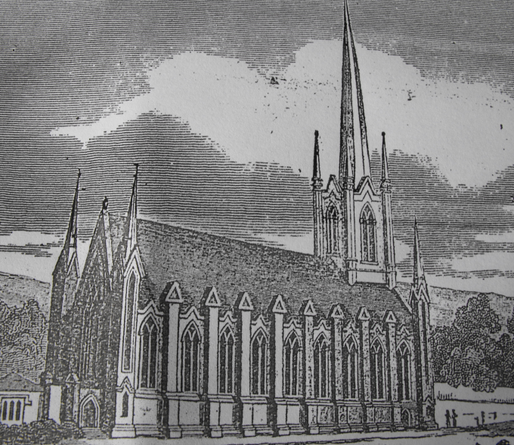

**Picture of Holy Trinity Church as shown in the *Dublin Penny Journal***

**Taken from a print of the original article framed in Holy Trinity Church**

Both the quote from the *Dublin Penny Journal* and the article by Peter Costello in his book appear to have some misunderstanding as to when Holy Trinity Church was built. This misunderstanding may arise from the fact that the article in the *Dublin Penny Journal* was written in 1833.

The Church was completed as a Chapel of Ease of the United Parishes of St Peter’s and St Kevin’s in Dublin, and consecrated for worship in 1828. On Sunday the 1st of June, 1828, which was the Feast of the Holy Trinity, the new church in Rathmines was consecrated to The Holy and Undivided Trinity for the worship of God by the Lord Archbishop of Dublin, the Most Reverend William Magee[9].

During his time as a student at Trinity College, Dublin Archbishop Magee (1766-1831) was a contemporary and friend of the Irish patriot Theobald Wolfe Tone although their political differences led Archbishop Magee to renounce the friendship in the 1790s. Archbishop Magee had been an ardent opponent of Catholic Emancipation[10].

**THE DEVELOPMENT AND GROWTH OF RATHMINES**

In his book on the *Dublin Suburban Towns*, Séamas Ó Maitiú illustrates why Rathmines in particular was favoured for development. He writes:

‘On the city’s boundary, the most promising area for the activities of speculative property developers was Rathmines and adjoining districts. Unlike Pembroke to its east, most of the land of Rathmines was in the hands of small owners as the Meath estate and other landlords had leased property on very long leases, sometimes up to 999 years, in the preceding century and a half…..because the land was held by lessees on such long leases, the interest of the Meath estate in the area was minimal. The only remnant of an estate was that of Lord Palmerston in Upper Rathmines. This absence of a large landowner controlling the supply of land made Rathmines ideal for the speculative builder.’[11]

Rathmines was becoming a prosperous district that developed into the second official township in Dublin in 1847. This formalisation of the township was prompted, to a major extent, by the distrust of the Dublin City grand jury system and its attempt to extend its remit to lands beyond its territory; the Southern boundary of Dublin City was the Grand Canal. Indeed, there are numerous examples of this distrust, even from the first part of the 19th century. Also, the question of rates appears to have had a major impact. Since Rathmines was controlled by property developers, it was in their interests to maintain low rates to encourage uptake of their speculative building. Thus, they had no interest in cooperating with Dublin City in joint developments, or purchasing essential supplies from Dublin. In Neil Hegarty’s book he writes ‘the authorities of Rathmines seem to have been a good deal more concerned with maintaining low rates of local taxation than in investing to any great extent in the township’s infrastructure. When gas street lamps were introduced into Dublin City in 1824 the authorities in Rathmines declined the offer to establish a similar lighting system throughout its jurisdiction, on the grounds of expense.’[12]

Gas street lighting was not introduced into Rathmines until 1848, after the Town commissioners had entered into a contract with the Alliance and Dublin Consumers’ Gas Company.[13]

These feuds with Dublin did not affect the growth of Rathmines and it continued to expand and develop rapidly. To give an indication of this the population details of the Rathmines Wards, as extracted from the Censuses data for the Barony of Uppercross for 1841, 1851 and 1861, show

[14]

In subsequent censuses data Rathgar was included with Rathmines and it was listed as a separate Township. Additional data was collected in the censuses, including religion. Reviewing the Protestant Episcopalian information gives a very good indication of the Protestant image of Rathmines, especially its dramatic growth in the 1871/1881 period.

[15]

Indeed, my own family connections with Rathmines go back to 1873. My WILLIAMS great-grandfather was resident at 137 Leinster Road, Rathmines at the time of his marriage to Mary Barrett[16]. My BESTICK great-grandfather’s connections to Rathmines date to 1880 when he took up residence in Frankfort Avenue, firstly in number 44 and subsequently in number 5[17].

**PARISH SCHOOLS**

The Parish school was built in 1852 and called the Township Schools and was located in Upper Rathmines Road. It was placed under a scheme framed by the Educational Endowment Commissioners in 1885 and was recognised as a National School by the Board of National Education in 1894. From the 4th January, 1897 it was divided into separate Boys’ and Girls’ National Schools. In 1919 the Boys’ and Girls’ schools were combined under one headmistress.

The Inspection Report of the 1st October, 1894 described the school as a one-story brick and lime constructed and slate roof structure that is leased for 800 years from the 8th June, 1852 at an annual rent of £20. On the date of inspection there were 20 boys and 25 girls in class and school-hours were from 10am to 3pm[18].

In 1913 the School Committee sought funds to improve the playground but the application to put down a ‘sort of asphalt covering’ was declined due to limited funds being available and the work not considered of sufficient urgency. Instead, the office of Public Works recommended that the playground might be rendered more suitable if sufficient gravel is spread from time to time.[19]

The schools continued as separate entities until the 1960s. At that stage the Church of Ireland College of Education had relocated from Kildare Place to Upper Rathmines Road, occupying the site of the former Rathmines Castle. As part of its legal charter the College of Education was obliged to have a Model School, for teaching purposes. It did not make sense to have two Church of Ireland National Schools located, and competing with each other for pupils, in such close proximity and they were merged together with the ‘KPS’ (Kildare Place School, the original name of the Model School being retained) taking over the pupils from the Rathmines Township Schools[20].

The Townships Schools building is now occupied by the Rathmines and Rathgar Musical Society although the original Boys’ School and Girls’ School separate entrances are still clearly visible on the building.

**THE DESIGN AND RE-BUILDING OF HOLY TRINITY CHURCH**

In 1854 alterations and re-painting was carried out in Holy Trinity but plans or descriptions have not been identified to show what work was undertaken. All that does exist of this happening is the Special Licence that was granted by the then Archbishop of Dublin to permit Divine Service to be ‘performed in the schoolhouse erected in the locality of said church’ during the work.[21]

In 1883, by Resolution of the General Synod of the Church of Ireland, Rathmines was divided from the United Parishes of St Peter’s and St Kevin’s and was created as a parish in its own right. The original parish boundaries extended from Kenilworth Square in the West to the D & SE Railway line in the East and from Cowper Road in the South to Portobello Bridge in the North. The Rev Samuel Musgrave Harris, MA, Curate of Harold’s Cross Church was appointed as the first rector and was instituted on the 16th June 1883. He remained as rector until his death in 1914. When Canon Harris arrived he came to a Parish without equipment of any kind save a church that could probably seat a total of 500 parishioners and a school. [22]

During his time many improvements were made to the parish. Holy Trinity Church was greatly enlarged, a new organ was erected, the parochial hall was built and the first rectory was purchased. All of this required money and it is reported that over a period of ten years three large bazaars were held that raised £12,000 towards these costs.[23]

To greatly enlarge Holy Trinity Church it was necessary to practically rebuild the original structure. A certain element of controversy surrounds the rebuilding. A new architect appears to have ‘arrived on the scene’ subsequent to plans being agreed by the Select Vestry and this delayed the process and resulted also in the ultimate cost being significantly higher than originally envisaged[24].

The work was completed in 1887 and it was described in *The Irish Builder*:

‘This suburban church, which within the past twelve months has been almost entirely rebuilt, was opened on the 6th inst. and re-consecrated by the Archbishop of Dublin. It now consists of nave, clearstorey windows, arches, and columns on either side, opening into a new north and south transepts, chancel, with triplet window, and panelled and moulded timber ceiling, and organ chamber with arches, opening into chancel and North transept. The organ has been entirely renovated by Messrs Telford and Telford, St Stephen’s Green … The building is thoroughly heated on the small bore high pressure principle, the pipes being laid with floor, thus avoiding objectionable grating coverings. On either side of passages the entrance porches are also well supplied with stacks of pipes, which will effectually prevent the possibility of cold draughts entering the building. This portion of the work has been executed by Messes Musgrave and Company, Belfast … The ventilation of the building specially provided for. At the intersection of nave and transepts roofs one of Ellison’s large exhaust ventilators, with spire roof, has been erected, and a plentiful supply of fresh air is passed into the building in a vertical direction through patent valve tubes which can be worked at will. The Church now accommodates about 1,000 sitters [sic]. We should not omit to mention the erection of a very handsome pulpit and reading stand, both of which are composed of Caen stone with highly polished marble columns and inlays with very elaborate carved caps, cornice, bosses, etc. The designs are by the architect, and the carrying out of this portion of the work was entrusted to Mr C.W. Harrison, 178 Great Brunswick Street. It is almost needless to say that they are of exquisite design, and reflect the greatest credit on both the architect and sculptor. Mr J.P. Pile, Great Brunswick Street, carried out the building contract, from the designs, and under the superintendence of Mr Alfred G. Jones, architect and civil engineer, 43 St Stephen’s Green.’[25]

To create the ‘open timber roof’ it had been necessary to demolish to original John Semple designed ‘old vaulted one of nave’ and only part of the west wall now remains from the original building. The vestry annex, on the south side was added at a cost of £500[26].

**PAROCHIAL HALL**

A purpose build two-storey parochial hall was constructed on a plot of land in Belgrave Square. Elizabeth Smith, in the paper that she undertook for her Certificate in Local History Studies, writes that this was the last building constructed on Belgrave Square until modern times.[27]

It was constructed at a cost of £2,000 and the heating and furnishings cost a further £2,400[28].

It included an apartment for the sexton and his family on the first floor. The architect was Frederick Augustus Butler. He was also a Rathmines Township Commissioner and he resided at 20 Leinster Square[29]. The builder was John Pemberton, Ranelagh Road. It was dedicated on the 31st May, 1900.

It remained in use until 1990 when it was sold to a developer. At the sale there were 22 bids before it was finally sold to an unnamed builder[30].

The picture below is an illustration of the ground floor plan of the parochial hall.



**Original plan of the ground floor of the Parochial Hall**

**From documents in the possession of the Rev Canon Neil McEndoo**

**RECTORY**

When Canon Harris arrived in the Parish there was no rectory. Correspondence dating back to September 1874 from the Hon. Secretary Rathmines Select Vestry to the Dublin Diocesan Council concerned the building of a ‘Glebe House for the Incumbent’ mentions that the Rt. Hon. W. Cowper Temple, MP had ‘kindly granted a suitable site, value for about £400 free of expense’ for this purpose. The letter goes on to explain that the building of the glebe would probably cost £1,000 and this money could be borrowed from the Board of Works under the terms of the Glebe Loan (Ireland) Acts 1870 and 1871. There was much backwards and forwards of correspondence and the proposal was still being discussed over 12 months later. The actual site was a half-acre one at the corner of Cowper Road and Palmerston Road but it was found that the glebe would cost about £1,800 to build and the matter was dropped ‘as the Select Vestry was not prepared to go beyond £1,200.’[31]

Subsequently, the parish rented No.19 Belgrave Square which it ultimately purchased (this is believed to have happened in 1904) for £750 plus repairs and re-decorations. This 11-bedroom rectory remained in use until the 1930s[32].

An 11th September, 1935 letter from the Hon. Secretary of the Select Vestry to the Representative Church Body stated that ‘The Select Vestry of Holy Trinity Church, Rathmines at a meeting held on April 5th accepted the tender of £2,202-11s-6d of Mr Cowell for the building of the new Rectory, and instructed their Architect Mr Henry J. Lyons of 14 St Frederick Street to get the plans passed by the Corporation and the work put in hands as soon as possible, the lease for the site having been duly signed by both parties concerned. The Vestry have as a nucleus of a building fund £992 realised from the sale of the former rectory and have instructed me to apply to the Representative Church Body for a loan not exceeding £1,200.’[33]

The actual loan was for slightly in excess of this figure. The Annual Report and Statement of Accounts of Holy Trinity Church, Rathmines 1944-45 clarifies this.

‘The Rectory Loan of £1,211-16-7 from the Representative Church Body, repayable over 35 years from 1st July, 1936, by an Annuity of £64-18-8[34]’

This new rectory is located opposite Holy Trinity Church on the corner of Purser Gardens, and remains in use today.

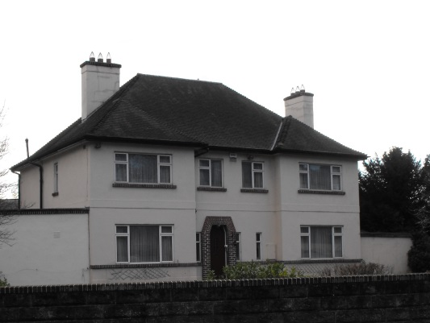

**Picture of the current rectory**

**Photograph by author**

**ORGAN**

‘The Parishioners are requested to take notice that a Citation has been issued from the Consistorial Court calling on them to show cause, if any, on or before the 4th July, why an Organ which has been purchased by private subscription should not be erected in the new Church of the Holy and Undivided Trinity at Rathmines. Published by me at St Peter’s Church on Sunday 21st June, 1829. (Signed) Henry Browning, Curate of St Peter’s.’[35]

Everything was conducted in a very formal manner in the 1820s and this notice was properly displayed. It seems that no-one objected and the first organ was duly installed in Rathmines. Unfortunately, no further information is known about this first organ. However, Vestry Accounts for 1879 include items of expenditure such as “One Year’s salary to Organist £40-0s-0d” and ‘One year’s salary to Organ Blower £4-0s-0d and Gratuity to same £1-0s-0d’.[36]

In 1896 a new organ had been erected by Messrs Bishop and Son, London and this was re-built, as part of the Centenary Celebrations in 1928 by Messrs Conacher and Company of Huddersfield, at a cost of £769-7s-10d. Its re-dedication was reported in *The Irish Times*:

‘Last evening a large congregation attended in Holy Trinity Church, Rathmines, in connection with the re-dedication of the organ. The instrument was originally erected in 1896 by Messrs Bishop and Son, London and is now re-built by Messrs Conacher and Co., Huddersfield.’[37]

Organ concerts were often given in Rathmines, as reported in *Rathmines News and Dublin Lantern ‘*On Saturday afternoon an Organ and Vocal recital was given in Holy Trinity Church, when along with a couple of Organ pieces selections were given from the second part of ‘Messiah.’ Mr Revelle played Handel’s ‘Fifth’ organ concerto and the Pretty Largo. The choruses of the ‘Messiah’ ……..were efficiently performed by the Choir.’[38]

**STAINED GLASS WINDOWS**

There are a number of stained glass windows in Holy Trinity Church. There are three large windows: at the East End, in the North Transept and in the South Transept. There are three other smaller stained glass windows: two in the South Transept and one in the North Transept. This latter window was originally located in the exterior wall but, after recent renovations it was re-mounted on an interior wall. This window was purchased by subscription as a memorial to Andrew Bell, a prominent member of the Parish for many years. It was designed by the stained-glass artist Alfred Ernest Child.

Child was born in London in 1875 and studied stained-glass with Christopher Whall. In 1901 he was invited to Dublin to practice his craft and to teach at the Metropolitan School of Art. In 1903 he became the part-time manager of Sarah Purser’s new stained-glass workshop, An Túr Gloine at 24 Upper Pembroke Street[39].

The 1911 census shows him living in 12 Frankfort Place with his wife and three children.[40]

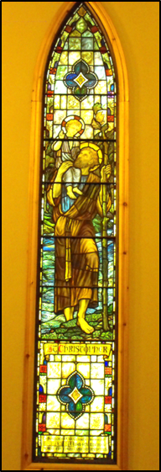This stained glass window was dedicated at a service that was held in January, 1925. The Parish Magazine records ‘*Brilliant sunshine, which lifted our thoughts from the shadows of earth to the glories of Heaven, flooded the church on Sunday January 4th, when St Christopher’s window was unveiled and dedicated*’.[41]

Of all of the stained glass windows in Holy Trinity Church this one has particular relevance to me since it is because of this window that I was given my name, Christopher.

**St Christopher’s stained glass window**

**(Author’s photograph)**

**WAR MEMORIALS**

Following the Great War (1914-1919), Archbishop Barton, Archbishop of Dublin, issued a decree that all parishes must erect a memorial to commemorate those who lost their lives in the global conflict. The three-panel memorial in Holy Trinity Church is of carved stone and is erected on the South Transept. It was designed by Mr R.C. Orpen FRIAI (he was a prominent Church of Ireland architect and elder brother of the painter William Orpen)[42] and executed by Messrs Sharp and Emery[43]. The Parish took great care to ensure accuracy of the names listed thereon and its cost was met by public subscription. A memorial service was held on the 12th June, 1921 at which the Bishop of Derry dedicated the memorial to those sixty men of the parish who laid down their lives during the Great War. The memorial is surrounded by framed Rolls of Honour that list 205 other members of the parish who also served in the Great War.

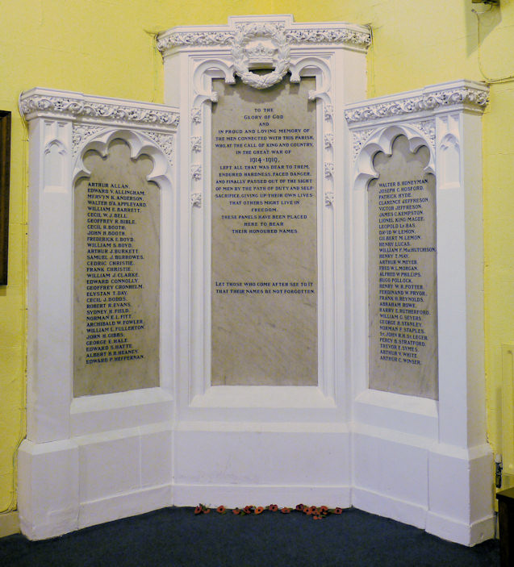

**Picture of the World War I memorial**

**(Courtesy** [**www.irishwarmemorials.ie**](http://www.irishwarmemorials.ie) **website)**

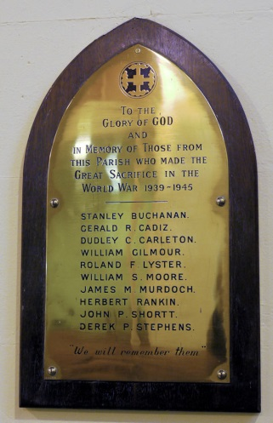The smaller Second World War (1939-1945) memorial contains the names of ten members of the parish who lost their lives and the two framed Rolls of Honour list a further 94 names of those who served with the Allies. It may be in recognition of the changing times and attitudes that these latter scrolls include the names of 23 women who also served with the Armed Forces of the Allies.

**Picture of the World War II memorial**

**(Courtesy** [**www.irishwarmemorials.ie**](http://www.irishwarmemorials.ie) **website)**

**MODERN DEVELOPMENTS**

Throughout the life of Holy Trinity Church both Parish boundaries and congregations have fluctuated. In the original John Semple church there was seating for approximately 500 people; the Alfred Jones church had seating for 1,000. From the 1960s it was obvious that regular congregations would not really be able to fill such a large space. To quantify this statistics from both the Baptismal and Marriage Registers[44] have been reviewed and they show the changes in numbers.

|  |  |  |
| --- | --- | --- |
| **Years** | **Baptisms** | **Marriages** |
| 1855/64 | 300 | na |
| 1865/74 | 493 | 224 |
| 1875/84 | 440 | 182 |
| 1885/94 | 383 | 215 |
| 1895/04 | 410 | 246 |
| 1905/14 | 322 | 397 |
| 1915/24 | 331 | 222 |
| 1925/34 | 194 | 126 |
| 1935/44 | 182 | 130 |
| 1945/54 | 139 | 95 |
| 1955/64 | 88 | 52 |
| 1965/74 | 89 | 81 |

There is no one reason for the decline in numbers of the Church of Ireland population, and church attending numbers, throughout the Republic of Ireland but a decline there has been and the Rathmines congregation was no exception

The reduction can be attributed to a number of factors. Colonial Retreat following Independence (Protestant members of the British Administration moving either to the North of Ireland or to England), Economic Emigration, War Deaths, especially from the First World War, Natural Decreases, the Vatican’s *Ne Temere* *Decree*, and the modern trend of lower dependence on religion.

In 1977 it was decided that Rathmines Parish would be amalgamated with Harold’s Cross Parish and Holy Trinity would assume the role of ‘Mother Church’ to the enlarged parish. Ultimately the church in Harold’s Cross would be closed and its ownership was transferred to the Russian Orthodox Church. In the late 1980s it was decided that much work was needed in Holy Trinity Church, to correct dry-rot, to make the roof water-tight again, and to carry out other repairs, and to reduce the internal seating capacity to 250 while using some of the space thus created for rooms. It was also decided at that time to dispose of the Parochial Hall on Belgrave Square. Mr Denis Healy, Parish Architect, drew up the plans to create sufficient space within the church to replace the space lost by the sale of the Parochial Hall. By enclosing the Gallery and re-flooring it a greater floor space than that available in the Parochial Hall was created. The total cost for the repairs and alterations would amount to approximately £350,000. All of this was funded by the Parish, without the need for loans, through a combination of the proceeds of the sale of the Parochial Hall building and a very generous bequest from a Parishioner. The building work, which was carried out by Messrs Allen and Smith of Arklow, took six months and the Church was re-opened for Divine Worship at Christmas, 1990[45].

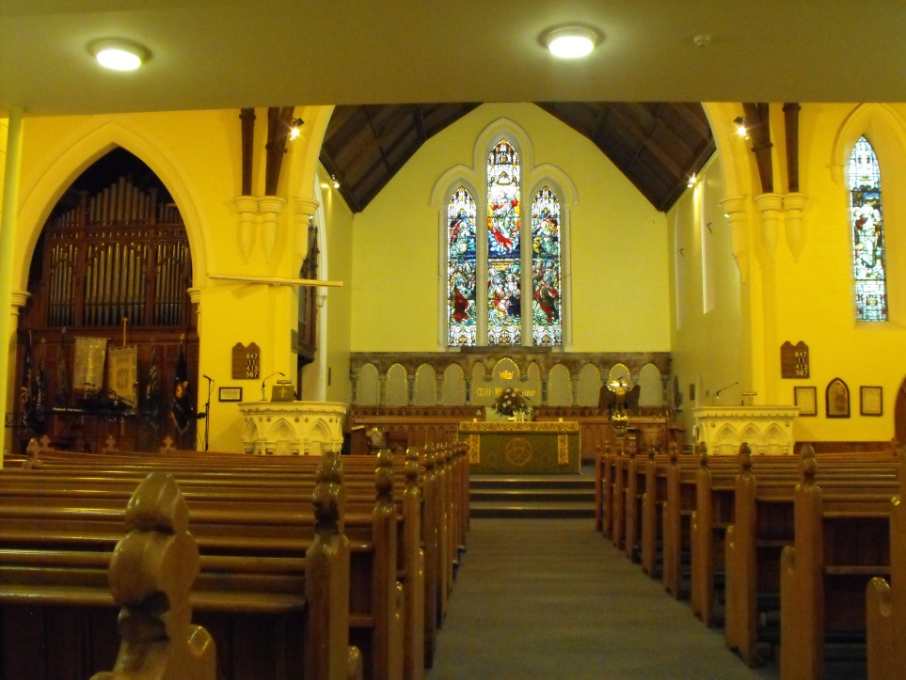

**Current (2014) interior of Holy Trinity Church**

**Author’s photograph**

Today, Holy Trinity Church is a living church and the parish has a strong and important future in the Church of Ireland and for Rathmines.

**BIBLIOGRAPHY**

**PRIMARY SOURCES**

**MANUSCRIPTS**

Certificate of Marriage of George WILLIAMS to Mary BARRETT (author’s papers)

Document ED/9/9154, National Archives of Ireland

Document ED/9/23381, National Archives of Ireland

Irish Censuses microfiche 1851, 1861, 1871, 1881, 1891, Dublin City Library and Archives, no reference numbers provided

Holy Trinity Church, Rathmines Parish Magazine (rector’s papers)

Loose Papers of St Peter’s Parish 1732-1962, RCB Library, reference box D6 117-118

Loose Papers of Rathmines Parish 1826-1977, RCB Library, reference box D6 82-83

Press File reference RWD 617, Irish Architectural Archive

Registers of Baptisms Holy Trinity Church, Rathmines, RCB Library references P545.2.1/5

Registry of Deeds folio 546131

Registers of Marriages, Holy Trinity Church, Rathmines, RCB Library references P545.3.1/12

Vestry Minutes 1807-34 St Peter’s Parish. RCB Library MS P45 5.4

**BOOKS**

Alex Thom and Co *Thom’s Official Directory of Ireland for the year 1846* (Dublin 1846), and for the years 1880/1890

*Fourth Report of the Ecclesiastical Commissioners (Ireland), 1837* (London 1838)

**NEWSPAPERS**

*The Irish Builder* 15th April, 1887

*The Irish Builder and Engineer*, 18 June 1921

*The Irish Times*, of Saturday 5th May, 1928

*Rathmines News & Dublin Lantern* April 4th 1896

**WEBSITES**

Irish census website [www.census.nationalarchives.ie](http://www.census.nationalarchives.ie)

Irish War Memorials website [www.irishwarmemorials.ie](http://www.irishwarmemorials.ie)

**SECONDARY SOURCES**

**MANUSCRIPTS**

Rev E.C. Hodges, BD Holy Trinity Church and its History, 1828-1928, Centenary pamphlet RCB Library Reference 274.183

**BOOKS**

Peter Costello *Dublin Churches* (Dublin, 1989)

Neil Hegarty *Dublin, A View from the Ground* (London, 2007)

Deirdre Kelly *Four Roads to Dublin* (Dublin 1995)

Ed James McGuire and James Quinn, *Dictionary of Irish Biography*, Volume 6 (Cambridge 2009)

Séamas Ó Maitiú *Dublin’s Suburban Towns 1834-1934* (Dublin 2003)

**WEBSITES**

Belgrave Square Residents’ Association website [www.belgrave-residents.org](http://www.belgrave-residents.org) Belgrave Square, Rathmines 1840-1940, by Elizabeth Smith, Written for the Certificate in Local History

Data base of the Irish Architectural Archive [www.dia.ie](http://www.dia.ie)

1. Deirdre Kelly *Four Roads to Dublin* (Dublin 1995) p165
2. Alex Thom and Co *Thom’s Official Directory of Ireland for the year 1846* (Dublin 1846)
3. Peter Costello *Dublin Churches* (Dublin, 1989) p144
4. Registry of Deeds, Kings Inns, Henrietta Street, Dublin. Book 810, Page 196, folio 546131
5. Loose Papers of St Peter’s Parish 1732-1962, Representative Church Body Library, Braemor Park, Churchtown, Dublin 14 (hereafter RCB Library), Reference box D6 117-118
6. *Fourth Report of the* *Ecclesiastical Commissioners (Ireland), 1837* (London 1838) p87
7. Vestry Minutes 1807-34 St Peter’s Parish. RCB Library MS P45 5.4
8. *The Irish Builder*, 15th April, 1887, Volume 29, p116
9. Rev E.C. Hodges, BD Holy Trinity Church and its History, 1828-1928, Centenary pamphlet RCB Library Reference 274.183
10. Ed James McGuire & James Quinn *Dictionary of Irish Biography* Volume 6 (Cambridge 2009) p242
11. Séamas Ó Maitiú *Dublin’s Suburban Towns 1834-1930* (Dublin, 2003) pp25-26
12. Neil Hegarty *Dublin, A View from the Ground* (London, 2007) p214
13. Séamas Ó Maitiú Dublin Suburban Towns 1834-1930 (Dublin, 2003) p103
14. Extracted from Irish Censuses data, 1841, 1851 & 1861 microfiche (no reference provided) Dublin City Library and Archives, Pearse Street, Dublin.
15. Extracted from Irish Censuses data, tables XXXI and XXXII 1871, 1881 & 1891 microfiche (no reference provided) Dublin City Library and Archives, Pearse Street, Dublin.
16. Details taken from the Certificate of Marriage of George WILLIAMS to Mary BARRETT.
17. Extracted from 1870/1895 *Thom’s Directories*, Dublin City Library and Archives, Pearse Street, Dublin. Reference 914/15.
18. Document ED/9/9154, National Archives of Ireland, Bishop Street, Dublin 8
19. Document ED/9/23381, National Archives of Ireland, Bishop Street, Dublin 8
20. Discussion with the current rector, Rev Canon Neil McEndoo
21. Box of loose Parish Papers Rathmines 1826-1977, RCB Library, Reference box D6, 82-83
22. Rev. E.C. Hodges, BD Holy Trinity Church and its History, 1828-1928, Centenary pamphlet RCB Library Reference 274.183
23. Rev. E.C. Hodges, BD Holy Trinity Church and its History, 1828-1928, Centenary pamphlet RCB Library Reference 274.183
24. Discussions with the current Rector, the Rev Canon Neil McEndoo
25. *The Irish Builder*, 15th April, 1887, Volume 29, p116
26. Discussion with the current Rector, the Rev. Canon Neil McEndoo
27. Belgrave Square, Rathmines 1840-1940, by Elizabeth Smith, Written for the Certificate in Local History and reproduced on the Residents’ Association website [www.belgrave-residents.org](http://www.belgrave-residents.org) (viewed 06/02/2014)
28. Discussion with the current Rector, the Rev. Canon Neil McEndoo
29. Data base of the Irish Architectural Archive [www.dia.ie](http://www.dia.ie) (viewed 13/02/2014)
30. Press File reference RWD 617, Irish Architectural Archive, 45 Merrion Square.
31. Box of loose Parish Papers Rathmines 1826-1977, RCB Library, Reference box D6, 82-83
32. Discussion with the current Rector, the Rev. Canon Neil McEndoo
33. Box of loose Parish Papers Rathmines 1826-1977, RCB Library, Reference box D6, 82-83
34. Box of loose Parish Papers Rathmines 1826-1977, RCB Library, Reference box D6, 82-83
35. Box of loose Parish Papers Rathmines 1826-1977, RCB Library, Reference box D6, 82-83
36. Report of the Select Vestry of the Church of the Holy Trinity, Rathmines Parish of St Peter 1879. Box of loose Parish Papers Rathmines 1826-1977, RCB Library, Reference box D6, 82-83
37. *The Irish Times*, of Saturday 5th May, 1928. [www.irishtimes.com](http://www.irishtimes.com) (viewed 23/01/2014)
38. *Rathmines News & Dublin Lantern* April 4th 1896. National Library of Ireland microfilm, no reference.
39. Irish Architectural Archive website [www.dia.ie](http://www.dia.ie) (viewed 23/04/2014)
40. Irish census website [www.census.nationalarchives.ie](http://www.census.nationalarchives.ie) (viewed 23/04/2014)
41. Article from the Parish magazine provided by the current rector, the Rev. Canon Neil McEndoo
42. Irish Architectural Archive website [www.dia.ie](http://www.dia.ie) (viewed 13/02/2014)
43. *The Irish Builder and Engineer*, 18 June 1921, p421 Irish Architectural Archive, Merrion Square, Open shelf book, no reference number
44. Registers of Baptisms Holy Trinity Church, Rathmines, RCB Library references P545.2.1/5 and Registers of Marriages, Holy Trinity Church, Rathmines, RCB Library references P545.3.1/12
45. Discussion with the current rector, Rev Canon Neil McEndoo